

Core Collection – Residential Facility Tracker (RFT)

- Responsibilities and Requirements
- Validation Tool
- Uploading RFT Data
- Promoting RFT Data
- Validating RFT Data
- Verifying RFT Reports
- Preparing/Finalizing RFT Data



TSDS RF Tracker Core Collection

TSDS RF Tracker – Submission Purpose, Responsibilities & Requirements

The TSDS data that is reported to the Education Data Warehouse (EDW) is a single resource for Texas local education agencies (LEAs), campuses and Education Service Centers (ESCs) to upload their data in a standard format for use with multiple applications. The data is used to provide educators with the ability to submit their required state and federal reports from a single source in a timely manner.

The purpose of the RF Tracker Collection is to oversee and monitor the programs provided to students with disabilities who reside in residential facilities (RFs).

RF Tracker data consists of two categories; Education Organization and Student and two sets of interchanges; Summer PEIMS and TSDS.

Districts will send their RFT data collection through the TSDS Portal in TEAL.

2022-2023 RFT Submission Timeline

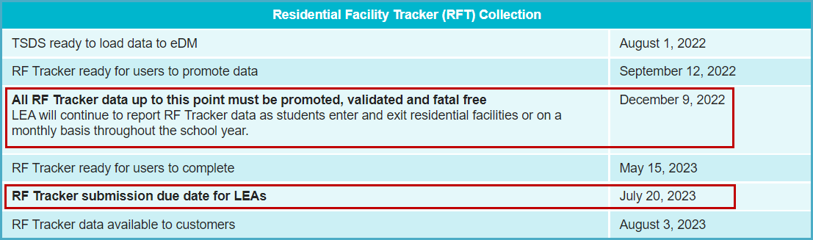

TSDS TEDS – Texas Education Data Standards

The data submitted through TSDS must be in XML format as defined in TEDS (Texas Education Data Standards). The TEDS is located on the TSDS website.

http://www.texasstudentdatasystem.org/TSDS/TEDS/TEDS_Latest_Release/

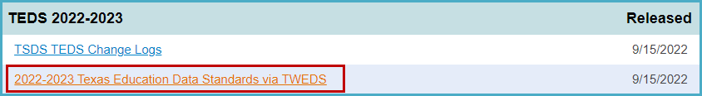

According to TEDS the LEAs (Local Education Agencies) are responsible for:

- Submitting current, complete, and accurate data for all XML files required for each submission
- Validating and editing data according to the business rules and validations
- Correcting all errors during the validation process
- Delivering “fatal-free” corrected data on or before any due dates set by the ESC or TEA.

TSDS TWEDS – eDM Dictionaries and Guides

TWEDS provides error dictionaries to assist in translating and troubleshooting errors in File Manager and Batch Manager as well as guides for deleting/reloading data. There is also a guide that cross-references validation rules with the associated elements and interchanges.

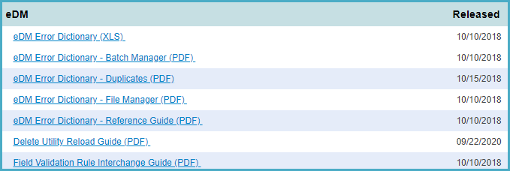

TSDS – Core Access and User Roles

The TSDS Core application is only available to authorized ESC, district, and campus staff. A TEAL logon is required as well as access to the Texas Student Data System Portal. Different roles can be assigned to the user based on the access required. There are six different roles in the Core application, each with a different level of access.

- ODS Data Loader (ESC/LEA) – This role allows the user to upload PEIMS and TSDS Interchanges to TSDS portal.
- Core LEA Data Viewer w/RF Tracker Access – This role allows the user to generate and view LEA Reports.
- Core LEA Data Promoter w/RF Tracker Access – This role allows the user to promote loaded data, validate (prepare) data and view submission data reports.
- Core LEA Data Completer w/RF Tracker Access – This role allows the user to promote loaded data, validate (prepare) data, complete (finalize) data and view reports at the district level.
- Core LEA Data Approver w/RF Tracker Access (LEA Superintendent) – This role allows the Superintendent to request an extension for the submission. The Superintendent does not approve this submission.
- Core ESC Data Viewer w/RF Tracker Access - This role allows the user at the ESC to view and monitor the submission.

Downloading Validation Tool – Version 12.0.0

TEA provides a Validation Tool to validate the format and naming conventions for the PEIMS interchanges. The Validation Tool is located in TEAL>Texas Student Data System Portal>Utilities for downloading.

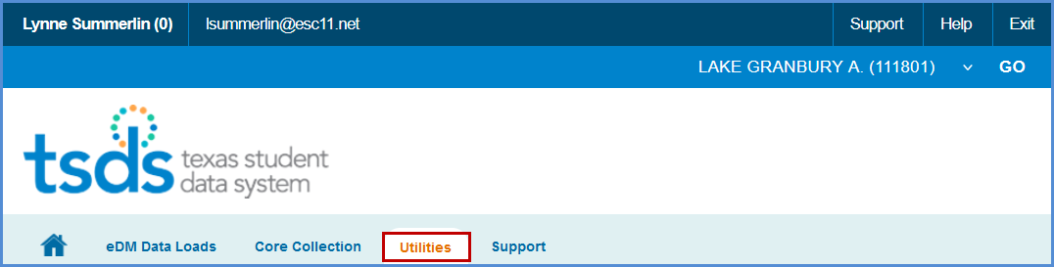
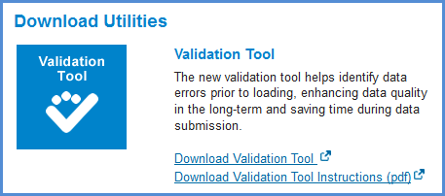

- Click Download Validation Tool to download the tool.
- Click Download Validation Tool Instructions (pdf) to download a copy of the installation instructions.

Validation Tool – Validating PEIMS & TSDS Interchanges

Once the Validation Tool has been downloaded and installed click on the validation tool icon to open the tool.

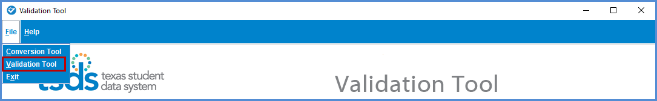

- Select File > Validation Tool. The Validation Tool opens in a separate window.

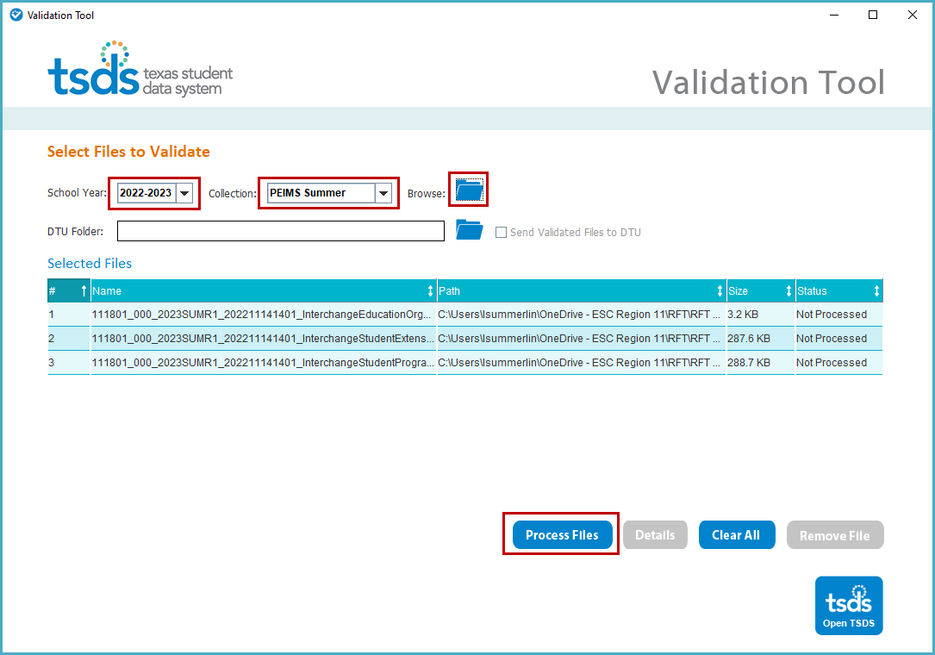

- Select the School Year 2022-2023.
- Select the PEIMS Summer Collection.
- Click the folder icon to browse for and select the PEIMS files (files must be unzipped).
- Click Process Files. The results of the validation are reported in the status field.
- If you have files that Fail, you can click on the file name and click the Details button.

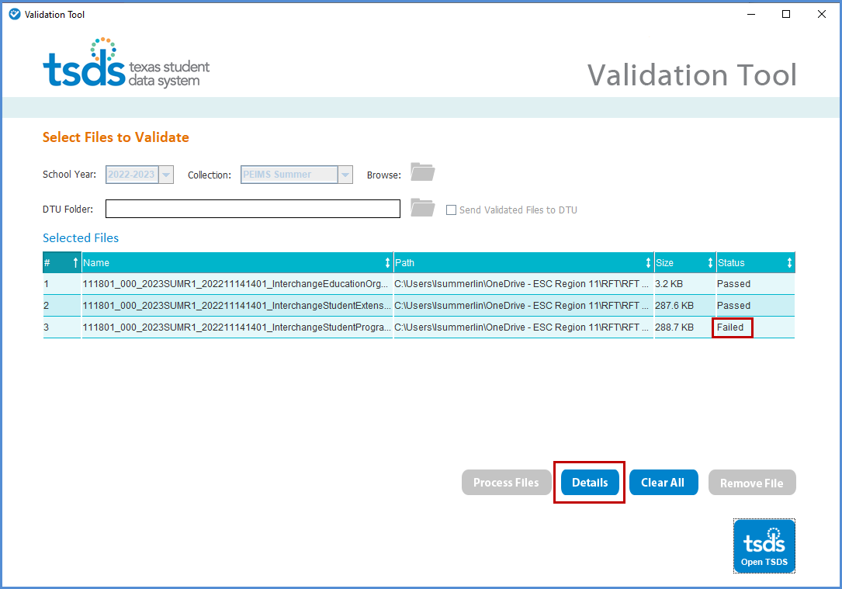

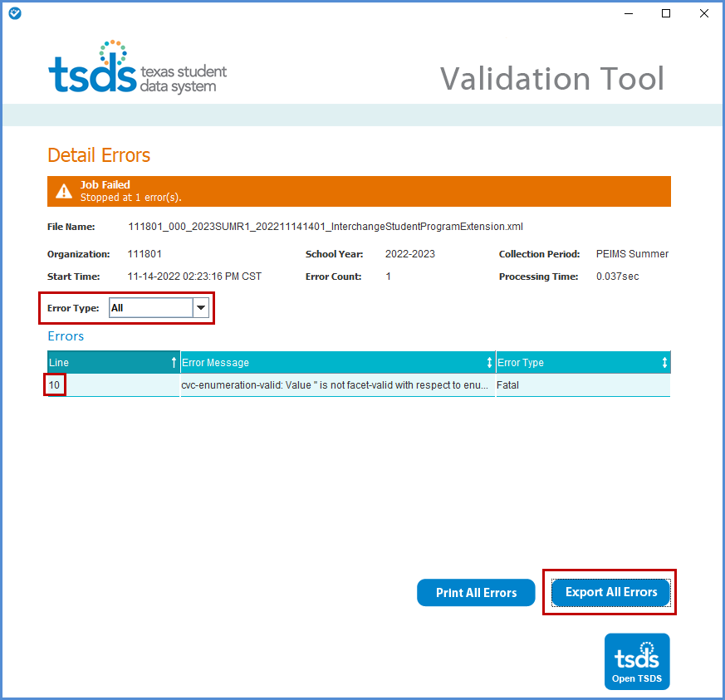

- The Detail Errors page appears, errors can be viewed on screen by selecting Error Type (All, Fatal, Warning, or Special Warning).
- Errors may also be printed by selecting Print All Errors or saved in Excel format by selecting Export All Errors.

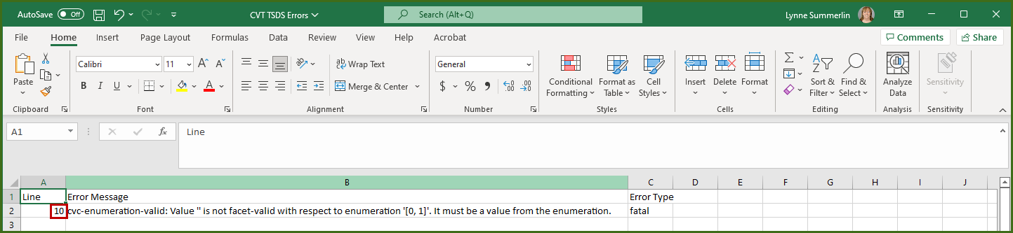

- Files can be manually loaded in TSDS by clicking on the Open TSDS button. This will take you to the TEAL login screen.

.
Note: Failed files will not load in TSDS. Files with errors will load, but errors will need to be corrected prior to finalizing the RFT Submission.

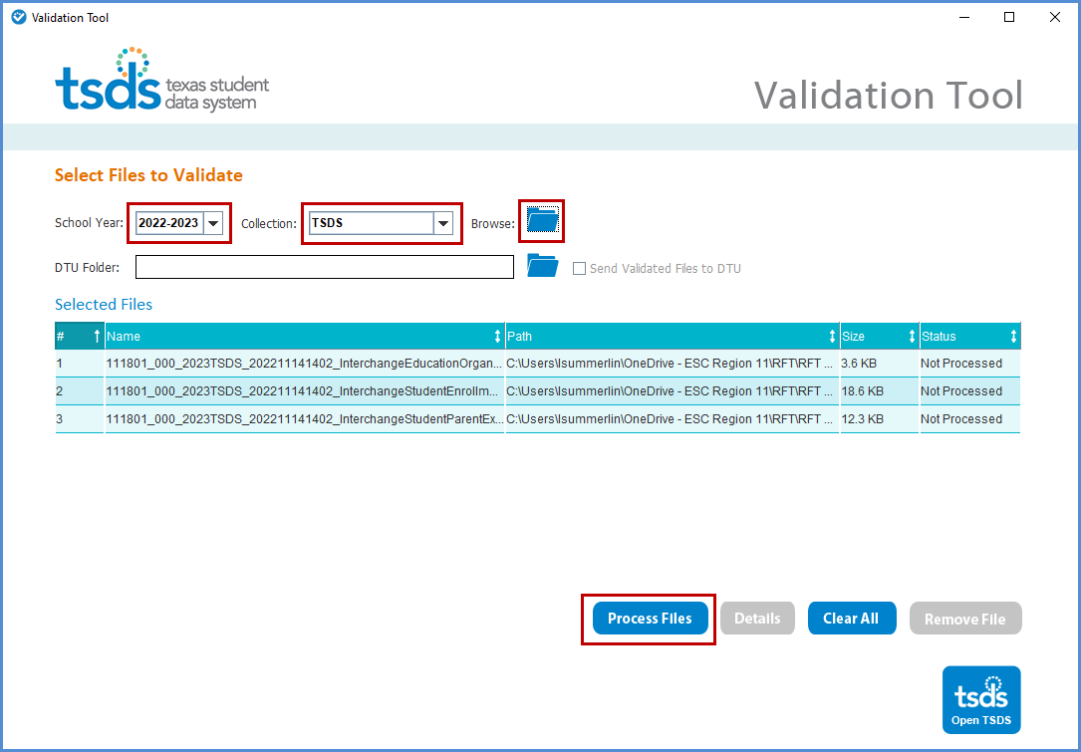

- Select the School Year 2022-2023.
- Select the TSDS Collection.
- Click the folder icon to browse for and select the TSDS files (files must be unzipped).
- Click Process Files. The results of the validation are reported in the status field.
- If you have files that Fail, you can click on the file name and click the Details button.

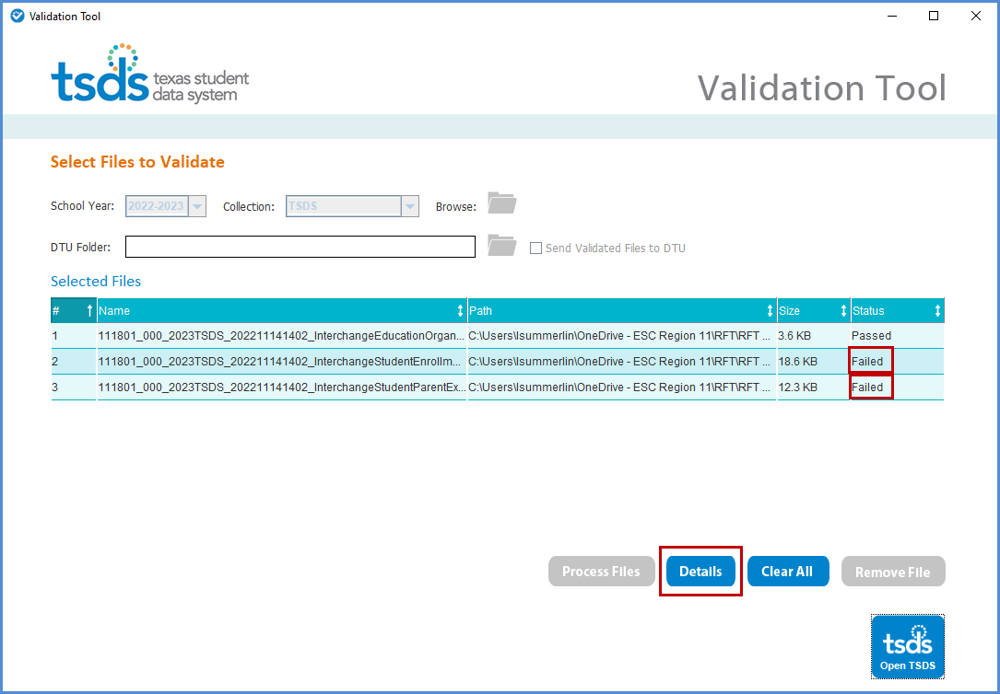

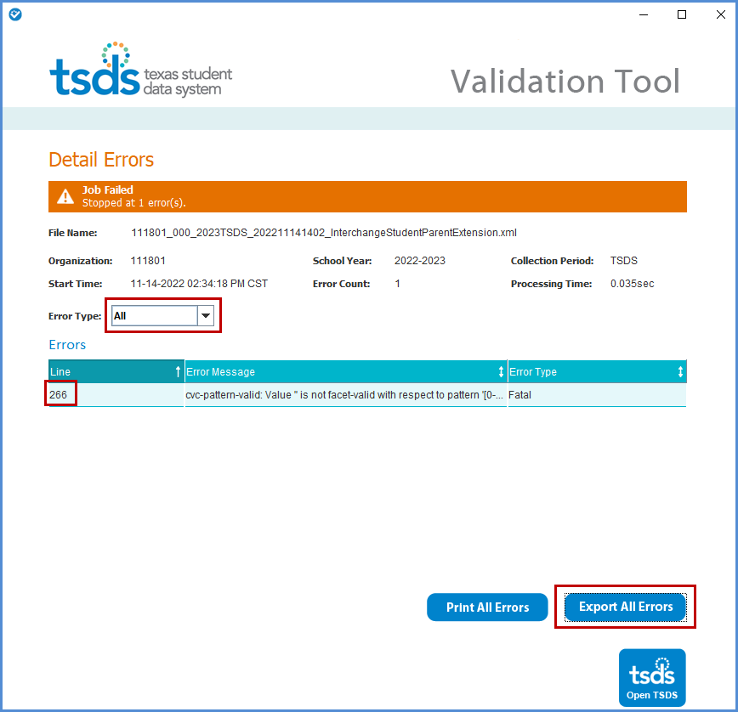

- The Detail Errors page appears, errors can be viewed on screen by selecting Error Type (All, Fatal, Warning, or Special Warning).
- Errors may also be printed by selecting Print All Errors or saved in Excel format by selecting Export All Errors.

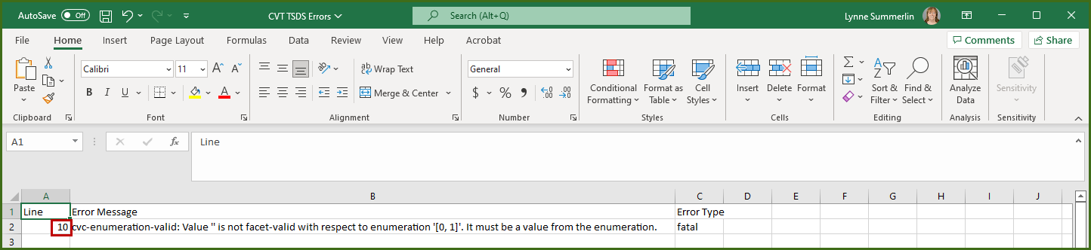

- Files can be manually loaded in TSDS by clicking on the Open TSDS button. This will take you to the TEAL login screen.
.
Note: Failed files will not load in TSDS. Files with errors will load, but errors will need to be corrected prior to finalizing the RFT Submission.

Uploading PEIMS files – PEIMS Data Upload

The TSDS portal is the way to access any of the TSDS applications or utilities to which users have rights. The tabs that appear on the portal depend upon the access that has been granted in TEAL.

The eDM Data Loads tool allows users to load data from their local systems to TSDS.

- Once logged into TEAL, select Texas Student Data System Portal.
- On the Home screen select Manage Data Loads.

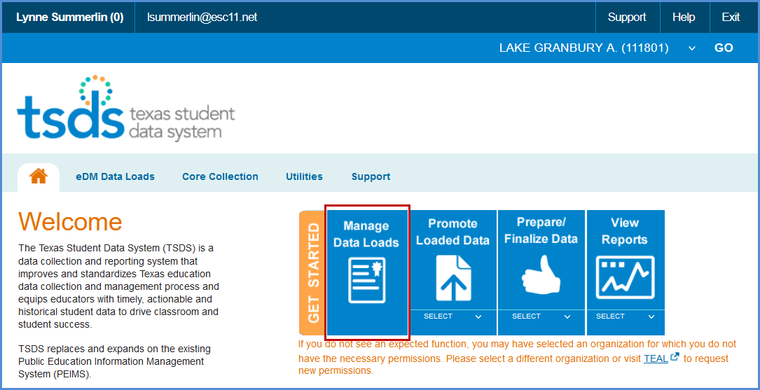

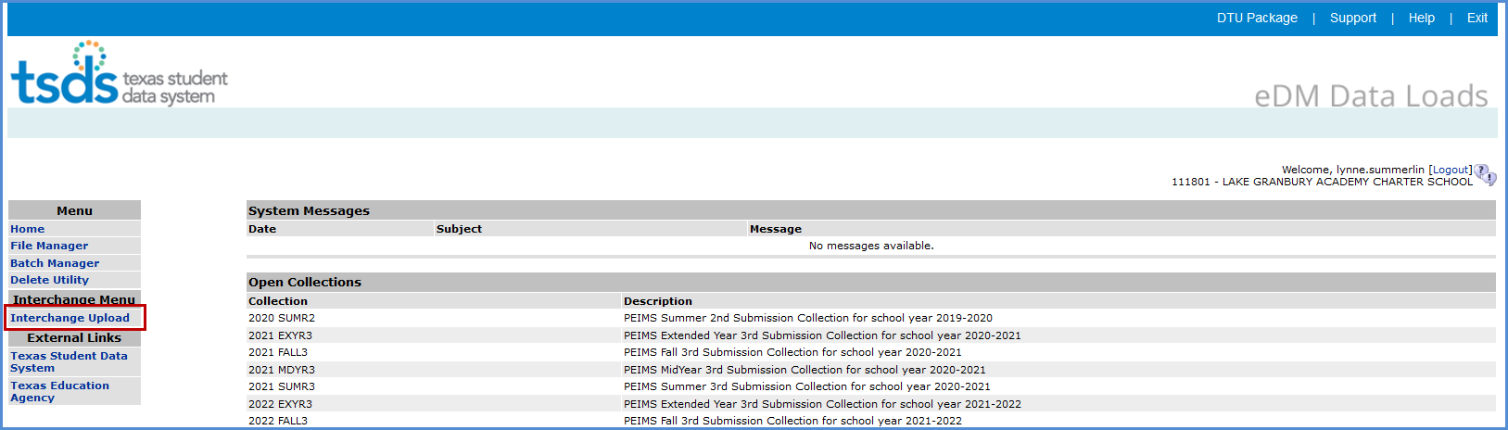

- Under Interchange Menu, select Interchange Upload.

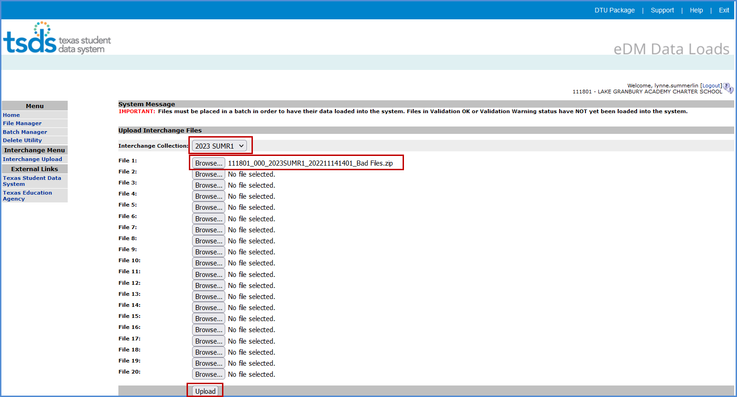

- Select the 2023 SUMR1 Interchange Collection from the drop-down menu.
- Click the Browse button for File 1 and select the file from your computer.
- Click the Browse button for File 2 and select the next file from your computer.
- Continue until all require files have selected.

Note: The files must be loaded in the following order:

- InterchangeEducationOrganizationExtension
- InterchangeStudentExtension
- InterchangeStudentProgramExtension

- Click Upload. The files are validated and uploaded to the File Manager.

Note: Files can be zipped for easier upload. Select all files, right click, Send to>Compressed (zipped) folder. Upload the one file.

Do not close this screen while files are uploading. You may exit once the File Manager screen appears.

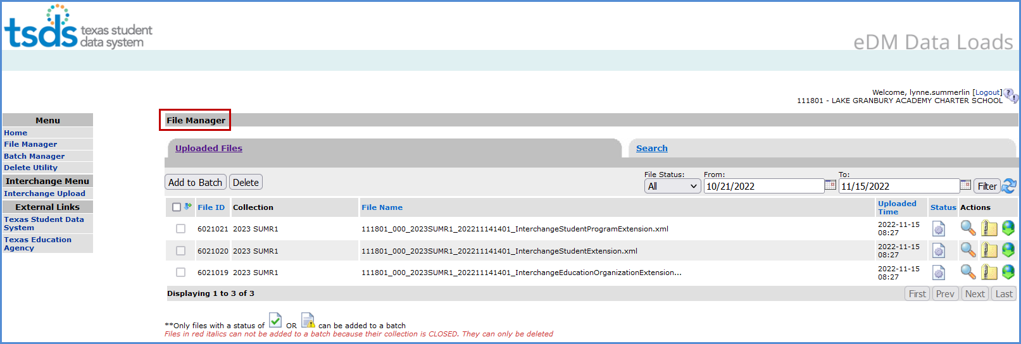
- Once the files have been completely uploaded, the File Manager screen appears.

- The files will be processed for errors.
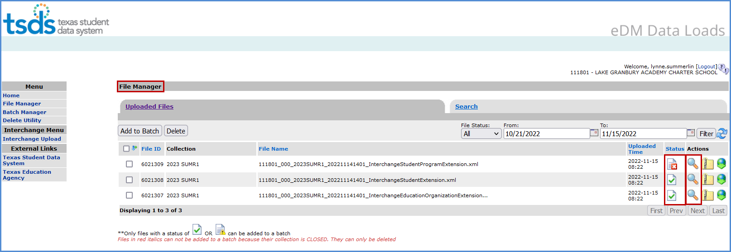

- Any failed files  will not batch.
- Any files with errors will have a red in the status column. To view errors, click on the spyglass and scroll to the bottom of the screen and open the .TAB file.

- Make all corrections necessary in the software, run the Validation Tool again, and resubmit the files.

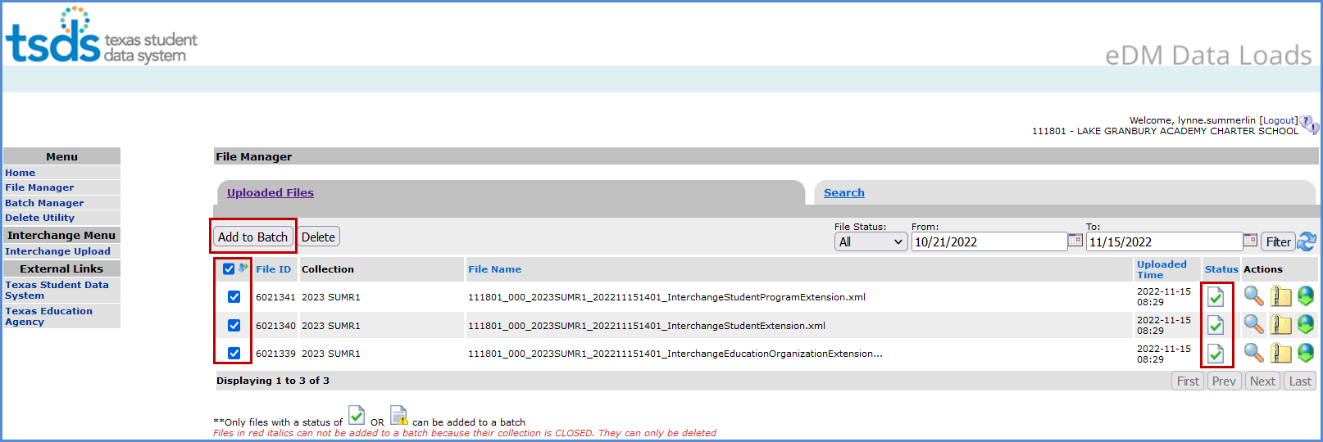
- Once all the files have a green checkmark in the status column, select all of the files and click Add to Batch. The View Batch button appears.
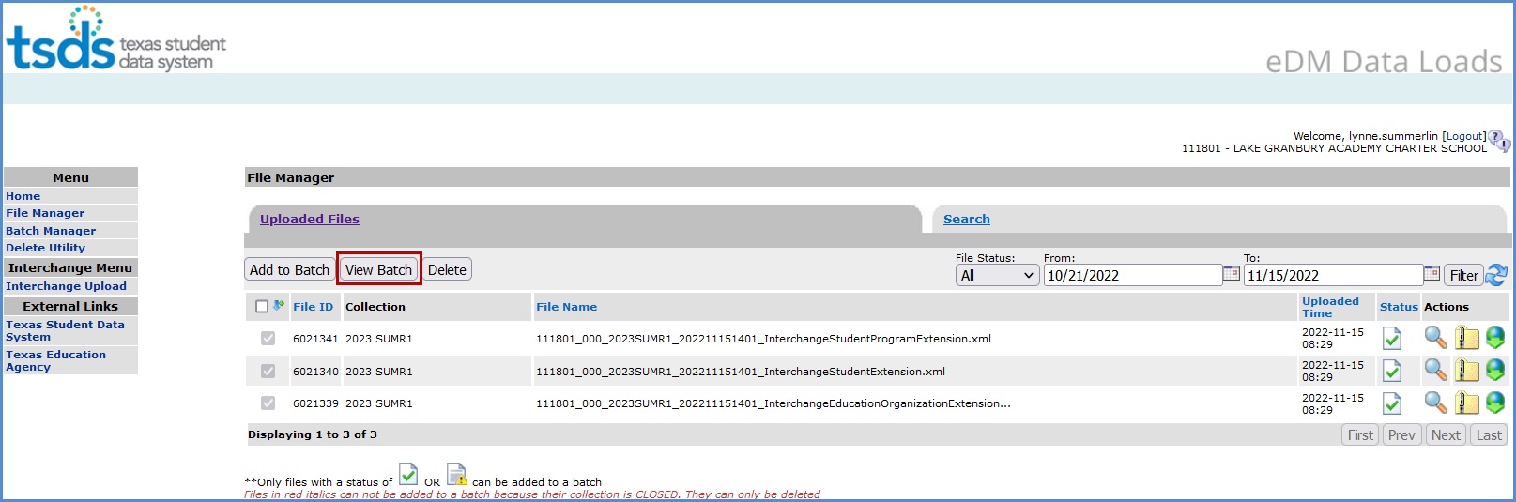
- Select the View Batch button.
- From the next screen the user may add comments regarding the batch, remove files from the batch, delete files, or process the batch. It is suggested that comments be added naming the file if the files are being uploaded manually.
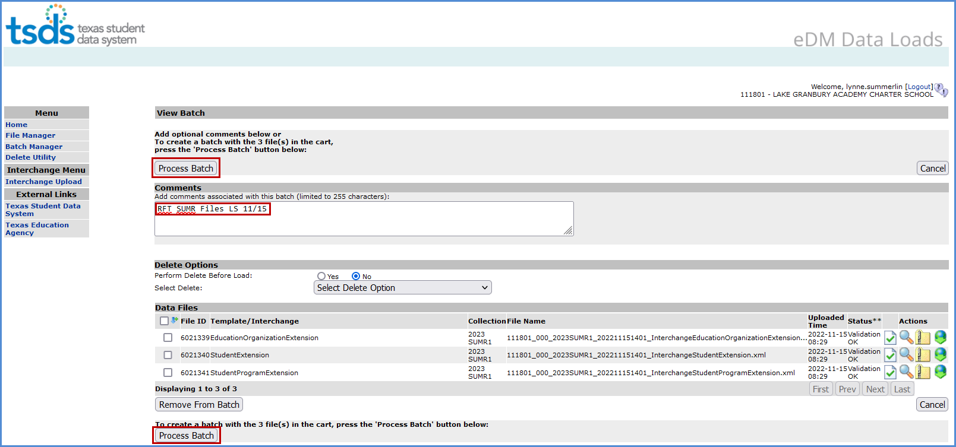

- To remove files from the batch, select the appropriate files and click Remove from Batch.
- The selected file is removed from the View Batch screen but remains in the File Manager.

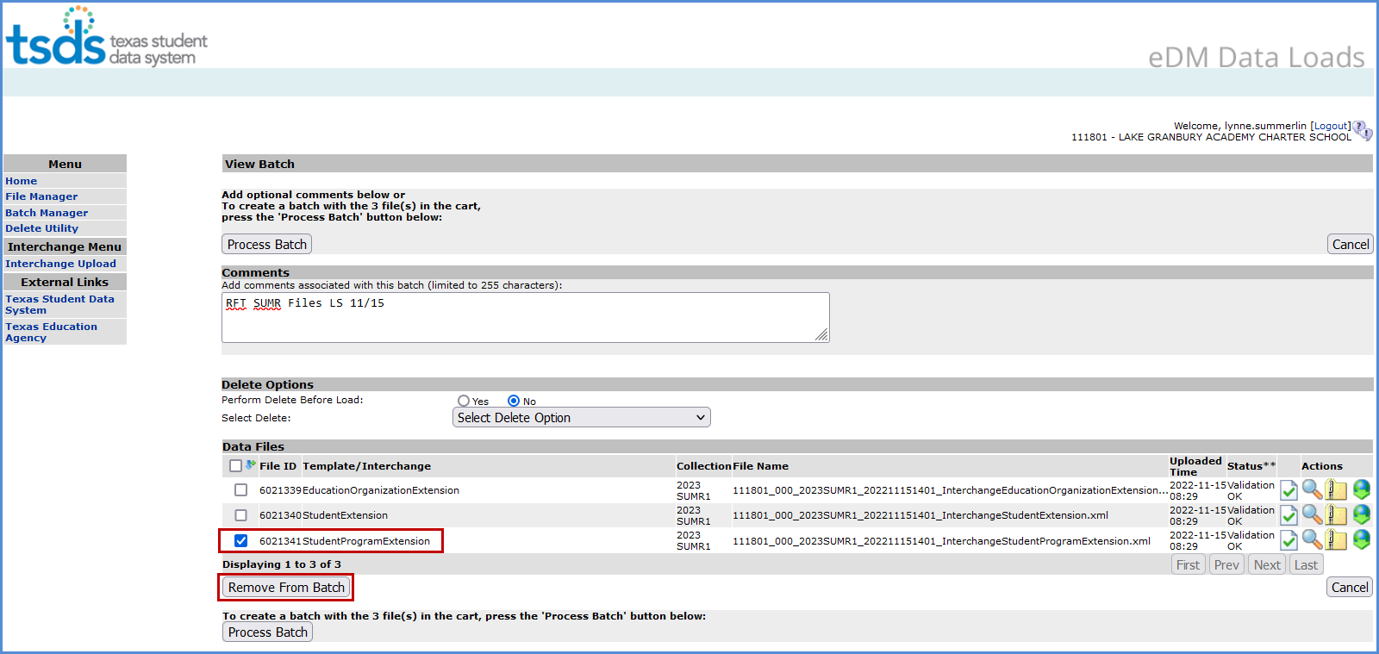

- Districts can delete data prior to processing the new batch. The Delete Utility has been integrated into the Batch Manager process.
- To delete data, select Yes by Perform Delete Before Load.
- From the Select Delete Option pulldown, select the data to be deleted.

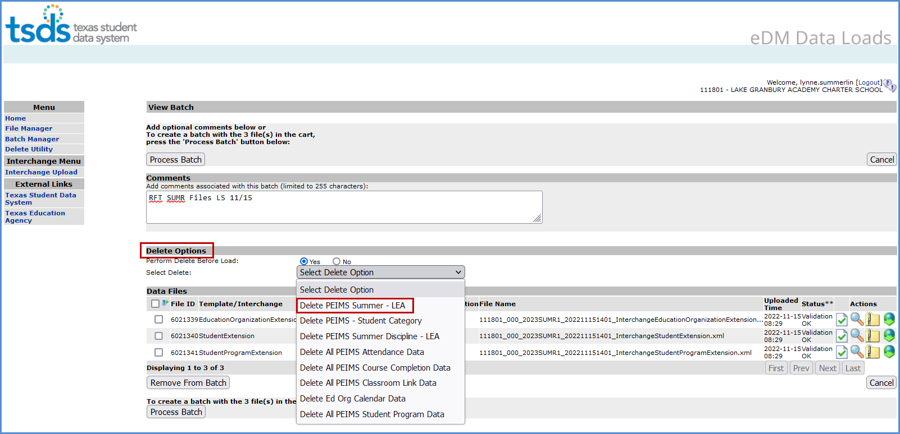

- To process the batch, select the appropriate files and click Process Batch. The Batch Manager screen appears:

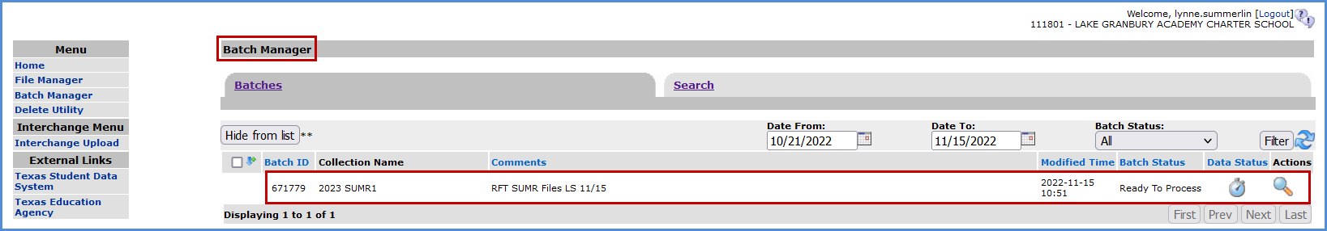

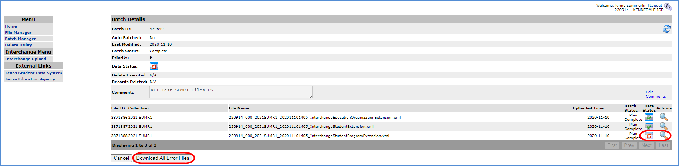
- The Batch Manager screen appears with a list and status of all batches that have been processed. Batches can have a completed status with errors (red X) or no errors (green checkmark).

- To view the files with errors, click the spyglass to open the batch and then click on the spyglass next to the file with errors; or
- Click on Download All Error Files.

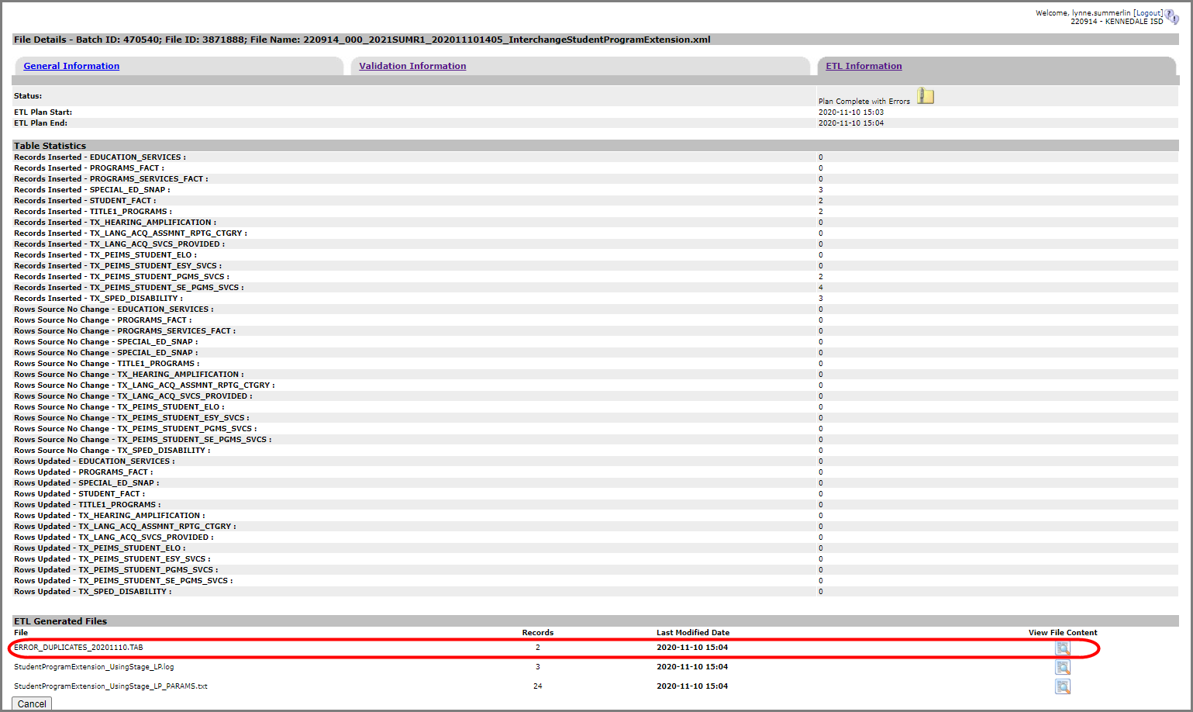

- To view the actual errors, click on the spyglass next to the .TAB file.

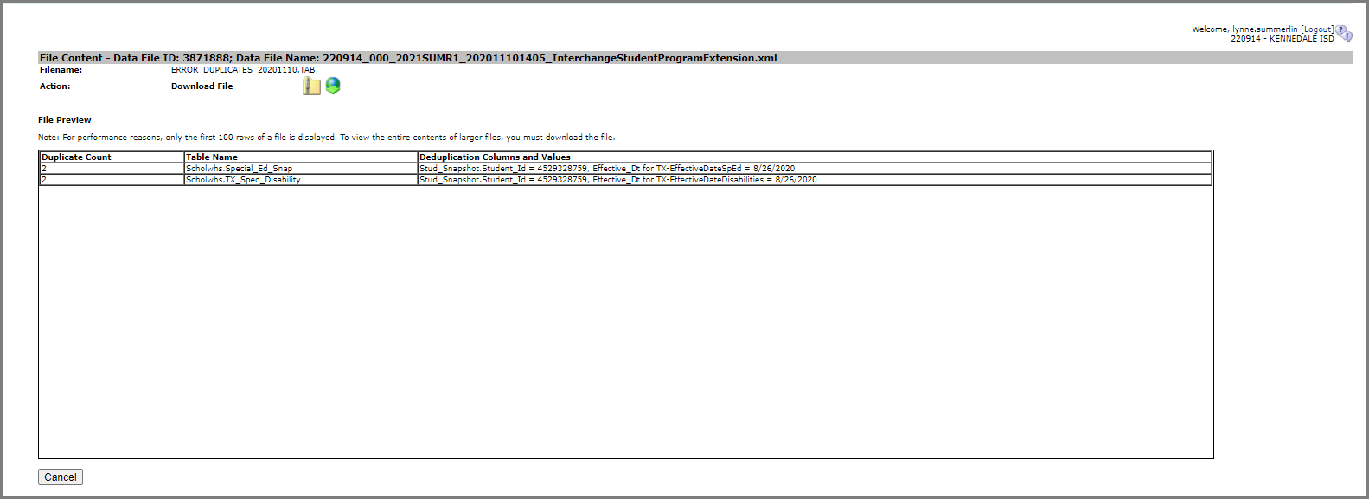

- Click Cancel to return to previous screens.
- Make corrections as needed in the software, create new interchanges, validate again, and resubmit the files.

Uploading TSDS files – TSDS Data Upload
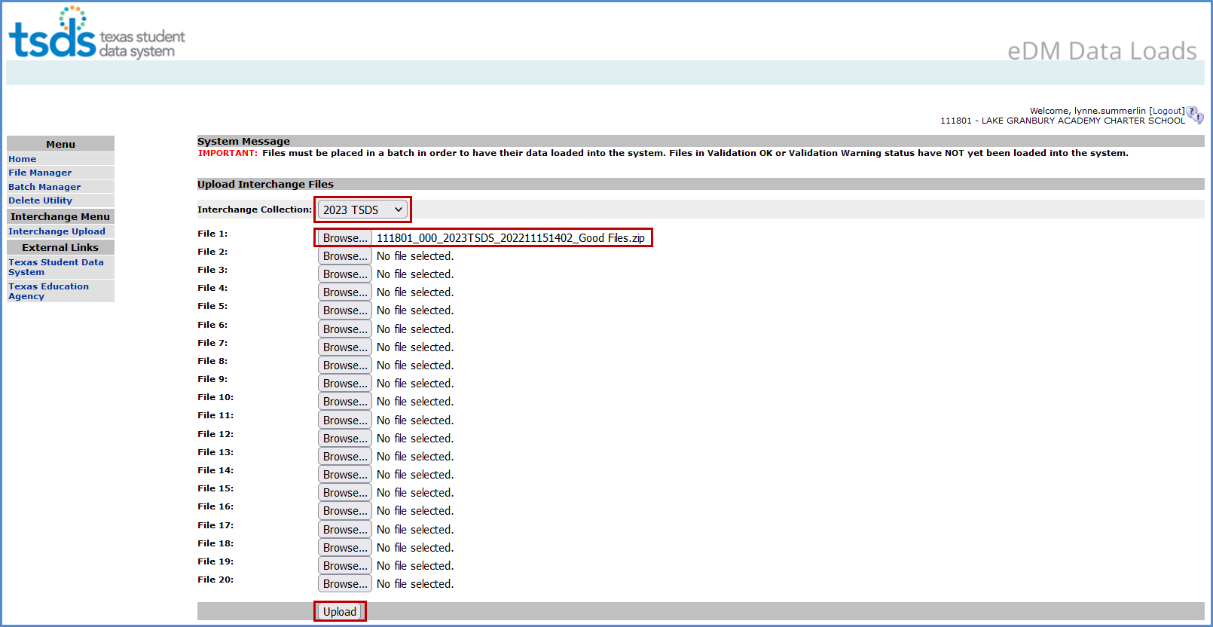

- Under Interchange Menu, select Interchange Upload.
- Select the 2023 TSDS Interchange Collection from the drop-down menu.
- Click the Browse button for File 1 and select the file from your computer.
- Click the Browse button for File 2 and select the next file from your computer.
- Continue until all require files have selected.

Note: The files must be loaded in the following order:

- InterchangeEducationOrganizationExtension
- InterchangeStudentParentExtension
- InterchangeStudentEnrollmentExtension

- Click Upload. The files are validated and uploaded to the File Manager.

Note: Files can be zipped for easier upload. Select all files, right click, Send to>Compressed (zipped) folder. Upload the one file.

Do not close this screen while files are uploading. You may exit once the File Manager screen appears.

- Once the files have been completely uploaded, the File Manager screen appears.
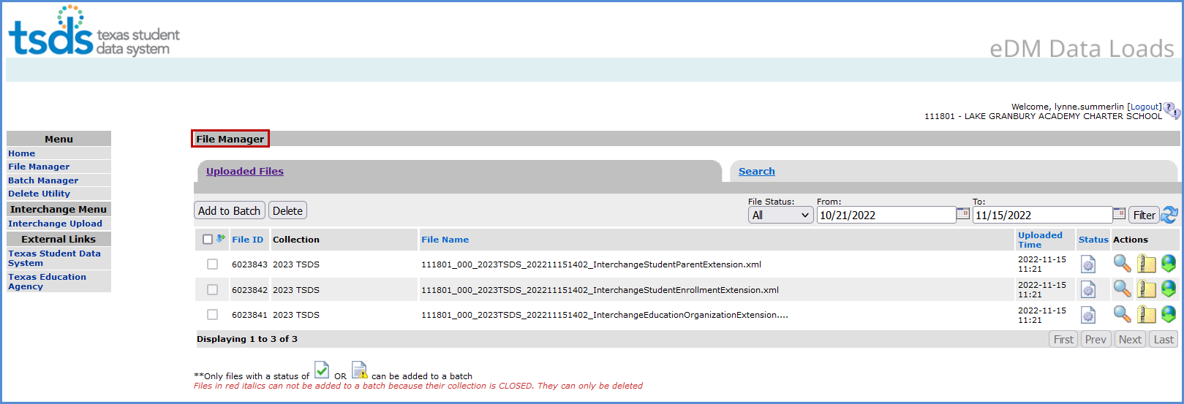
- The files will be processed for errors.
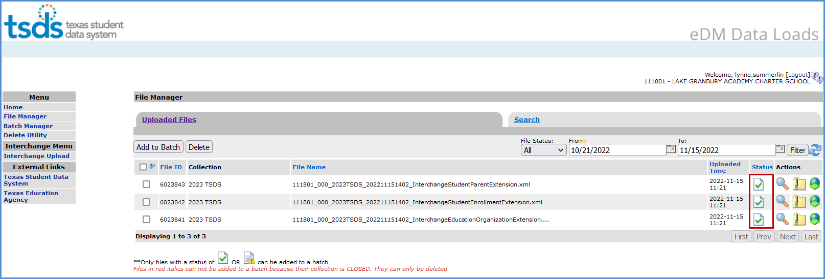

- Any failed files will not batch.
- Any files with errors will have a red in the status column. To view errors, click on the spyglass and scroll to the bottom of the screen and open the .TAB file.

- Make all corrections necessary in the software, run the Validation Tool again, and resubmit the files.

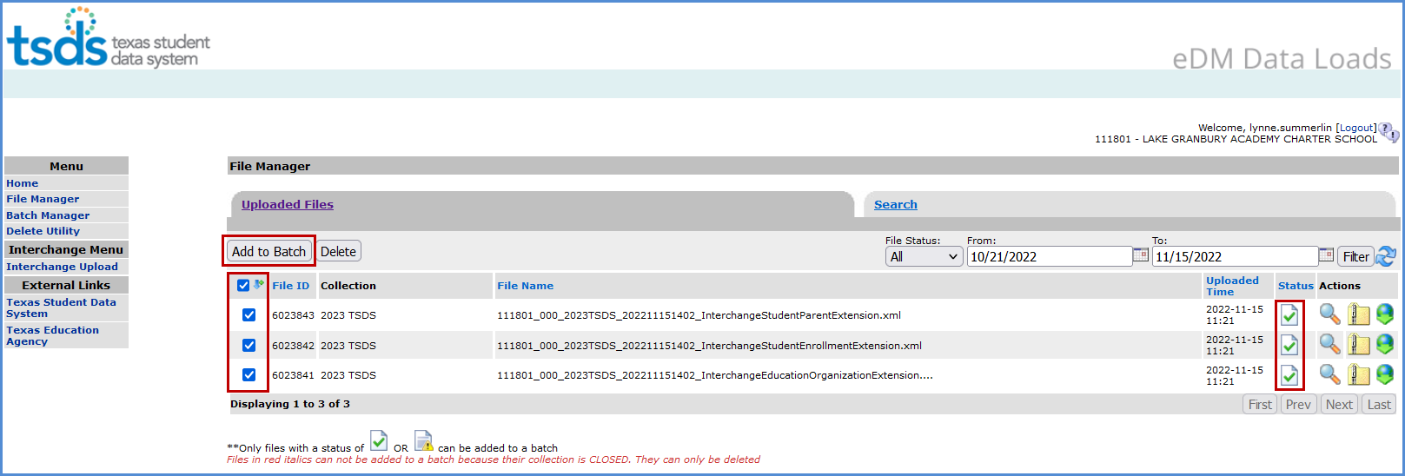
- Once all the files have a green checkmark in the status column, select all of the files and click Add to Batch. The View Batch button appears.
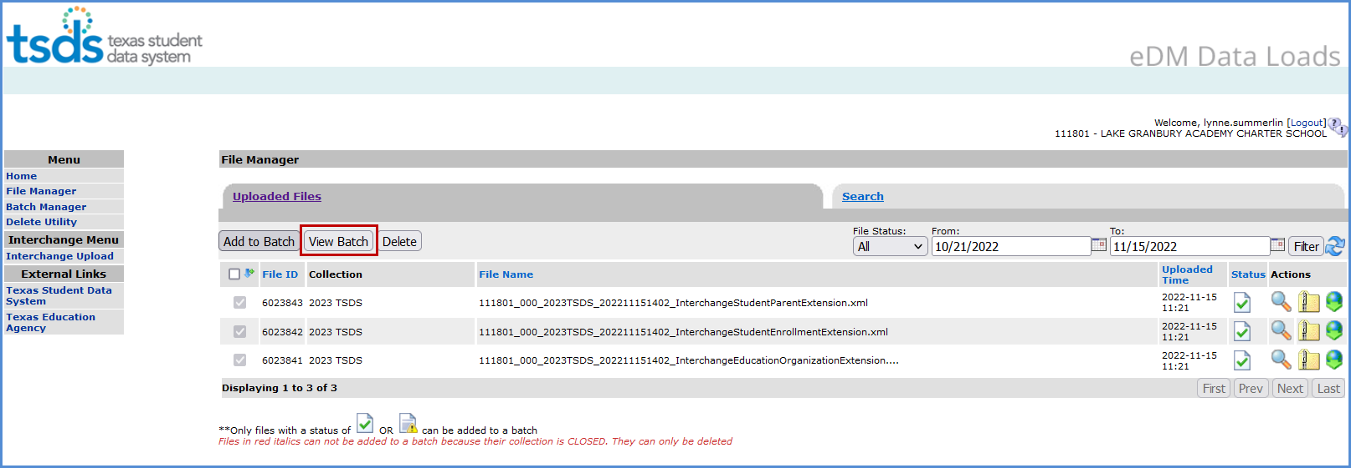

- Select the View Batch button.
- From the next screen the user may add comments regarding the batch, remove files from the batch, delete files, or process the batch. It is suggested that comments be added naming the file if the files are being uploaded manually.
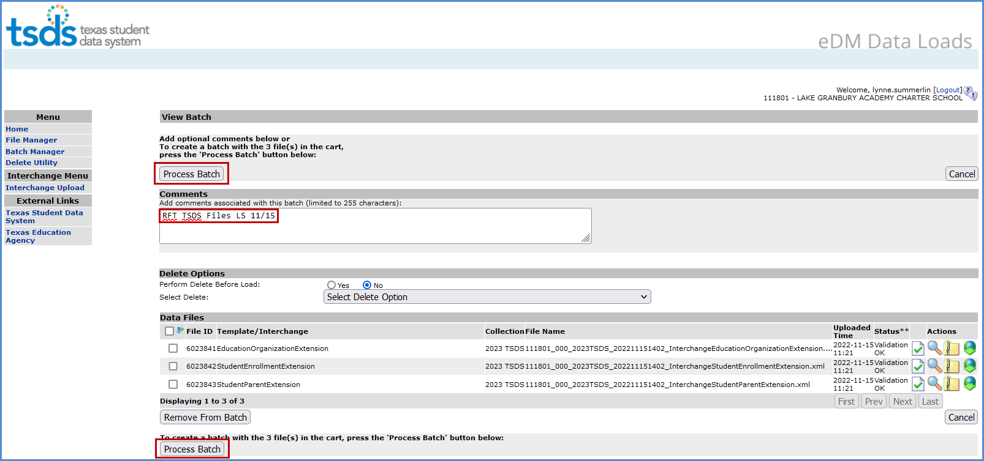

- To remove files from the batch, select the appropriate files and click Remove from Batch.
- The selected file is removed from the View Batch screen but remains in the File Manager.
- Districts can delete data prior to processing the new batch. The Delete Utility has been integrated into the Batch Manager process.
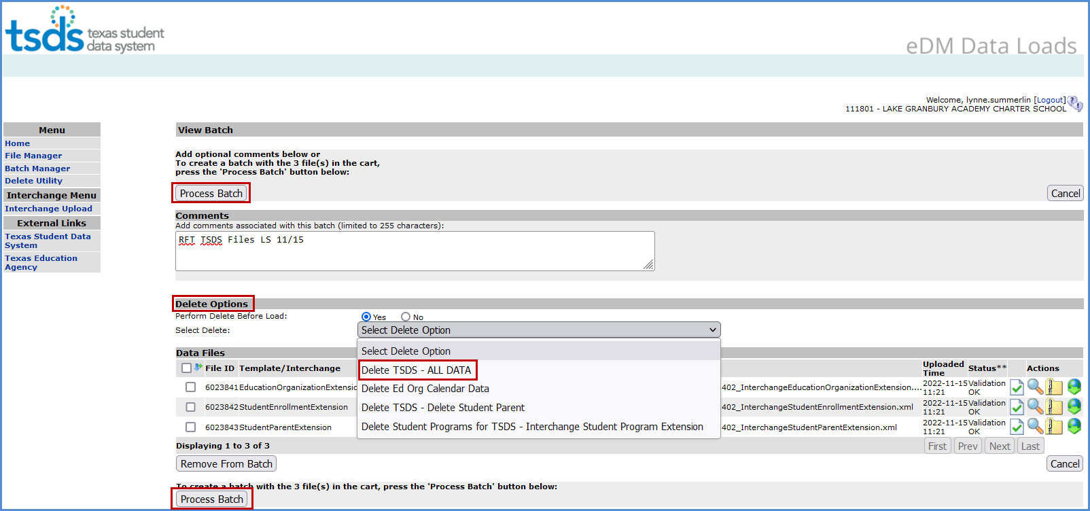
- To delete data, select Yes by Perform Delete Before Load.
- From the Select Delete Option pulldown, select the data to be deleted.

- To process the batch, select the appropriate files and click Process Batch. The Batch Manager screen appears:
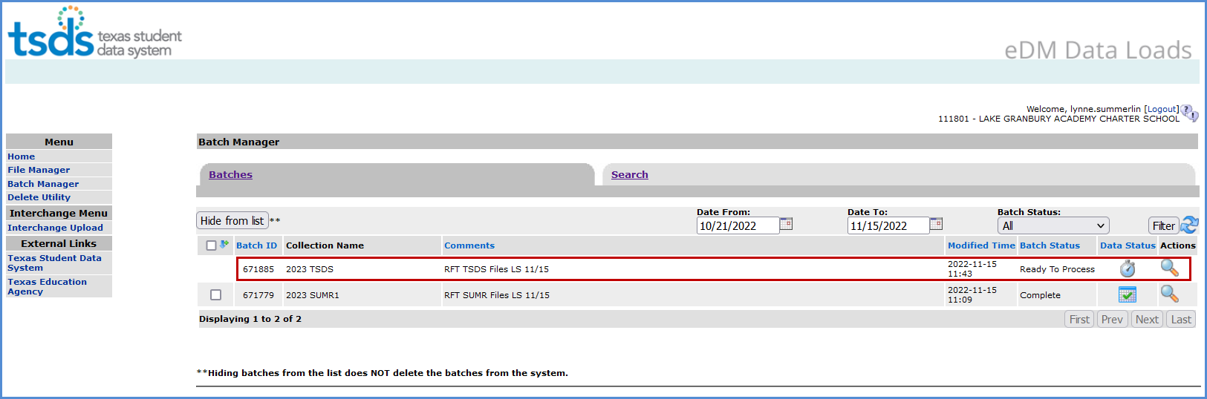
- The Batch Manager screen appears with a list and status of all batches that have been processed. Batches can have a completed status with errors (red X) or no errors (green checkmark).
- To view the files with errors, click the spyglass to open the batch and then click on the spyglass next to the file with errors; or
- Click on Download All Error Files.
- To view the actual errors, click on the spyglass next to the .TAB file.
- Click Cancel to return to previous screens.
- Make corrections as needed in the software, create new interchanges, validate again, and resubmit the files.

Promoting RFT files – Core Collection Promote Loaded Data

The eDM Promote Loaded Data tool allows users to promote data that has been loaded and batched.

- Log in to TEAL and select Texas Student Data System Portal.
- On the Home screen select Core Collection>Promote Loaded Data.
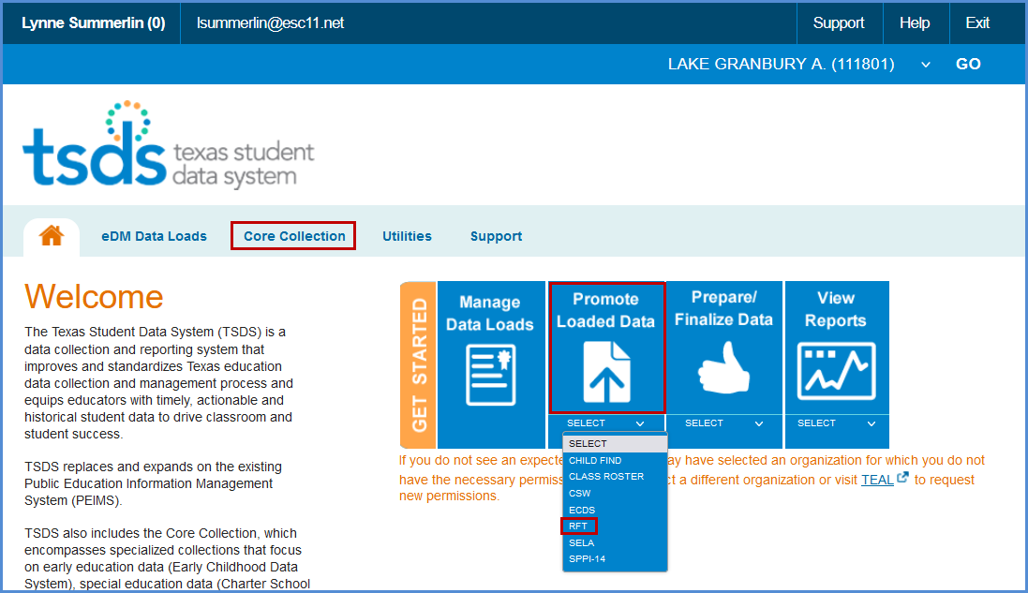

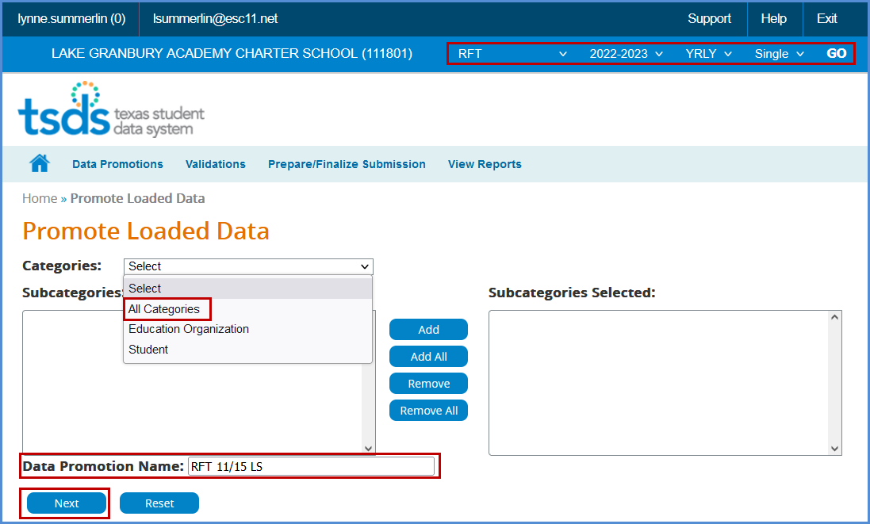
- The Data Promotion screen appears:

- Verify the correct submission is selected. If not, select it from the pull-down menu and click GO.
- From the Categories pull-down menu, select All Categories or the individual categories to be promoted. If individual categories are selected user may also select individual subcategories.

- Enter a Data Promotion Name.
- Click Next to continue or Reset to clear selections.
- The Confirm Data Promotion screen appears:

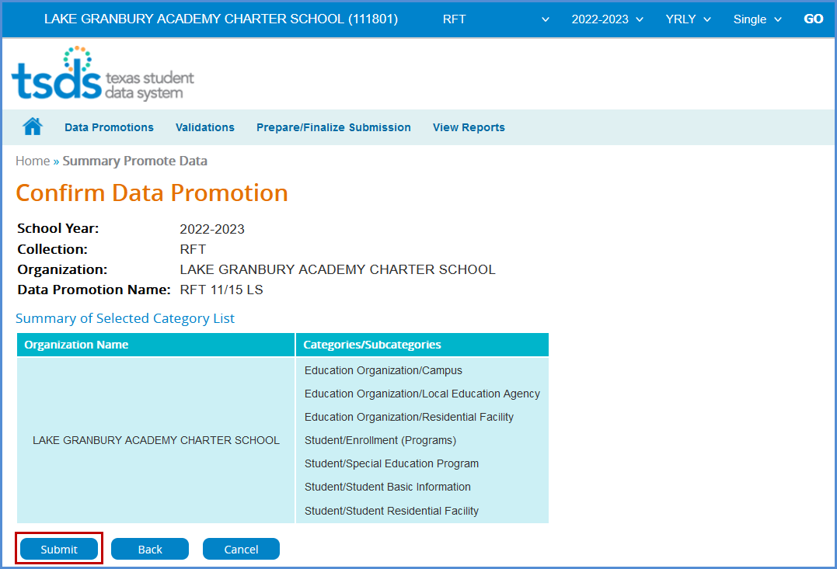

- Verify the Categories/Subcategories
- Click Submit, Cancel, or Back.
- The Monitor Data Promotions screen appears:

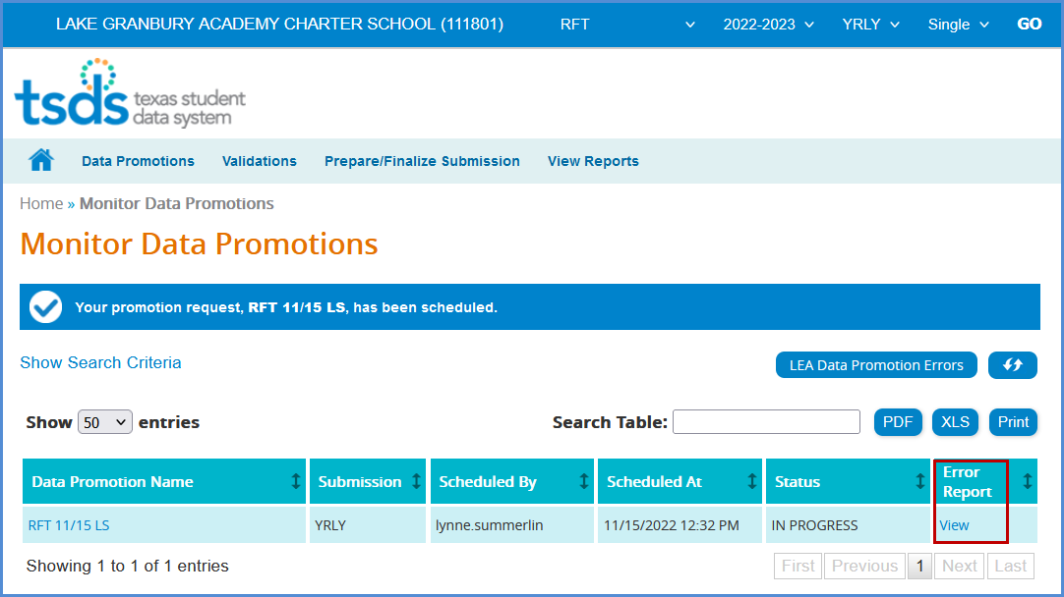

- This screen shows the status of the data promotion, promotion error reports, and a confirmation message that the data was promoted.
- To view any promotion errors, click the View link under Error Report or click the LEA Promotion Errors button.
- The Data Load Error Report by Job screen appears:

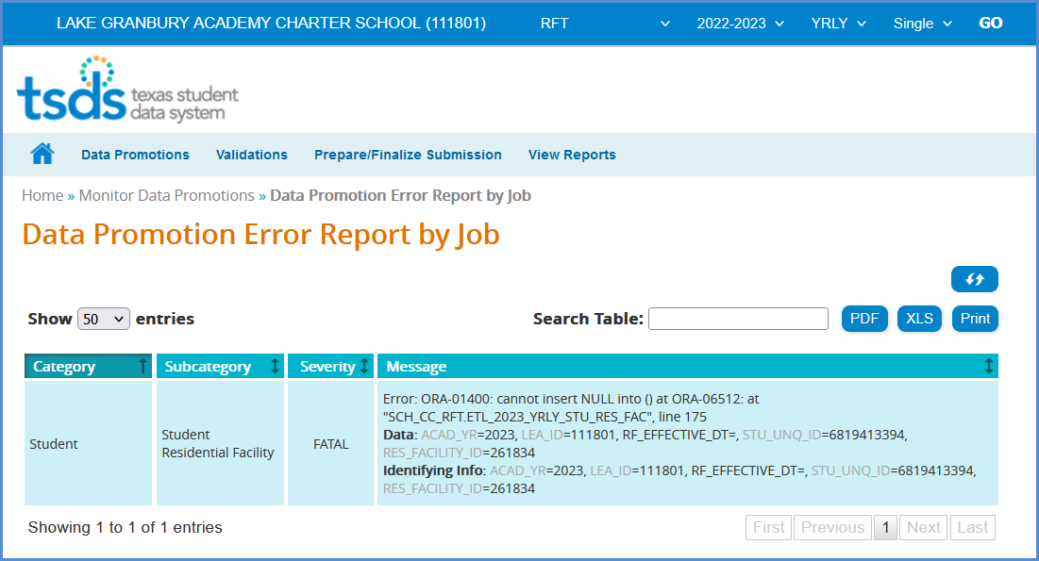

- This screen will list any errors by Category, Subcategory, Severity, along with the error message. Errors can be saved as a PDF or XLS file or can be printed by selecting the appropriate button.

Validating RFT files – TSDS Core Promote Loaded Data>Validations

The eDM Promote Loaded Data tool also allows users to validate data that has promoted in TSDS. This is where the district will be able to view the Fatals, Warnings, and Special Warnings for the submission.

- Log in to TEAL and select Texas Student Data System Portal.
- On the Home screen select Promote Loaded Data. Select the Validations tab>Validate Submission Data.

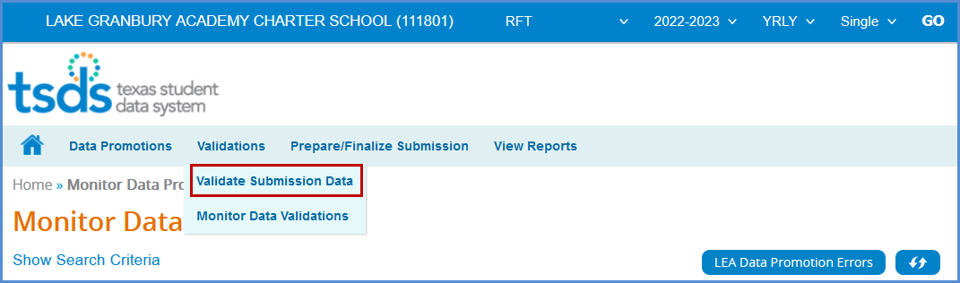

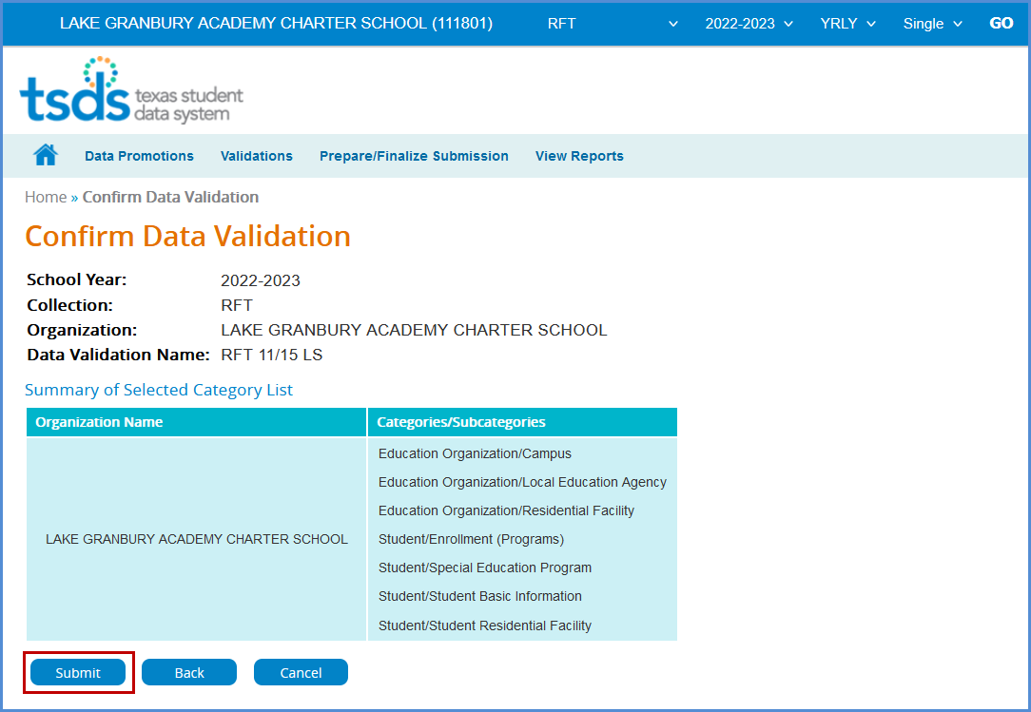
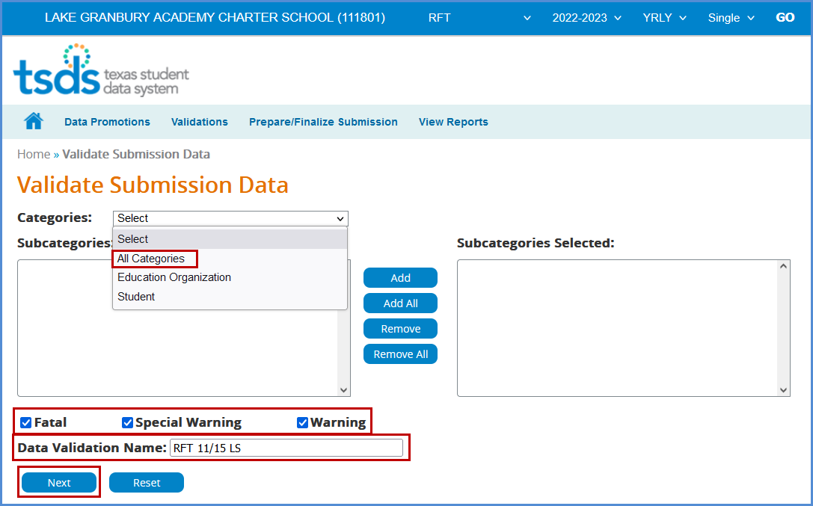

- From the Categories pull-down menu, select All Categories or the individual categories that are to be validated.
- Select the type of validation (Fatal, Warning, Special Warning).
- Enter a Validation Name.
- Click Next to continue the process or Reset to clear all options.
- The Confirm Data Validation screen appears:

- Verify the Categories/Subcategories
- Click Submit, Cancel, or Back.
- The Monitor Data Validations screen appears:

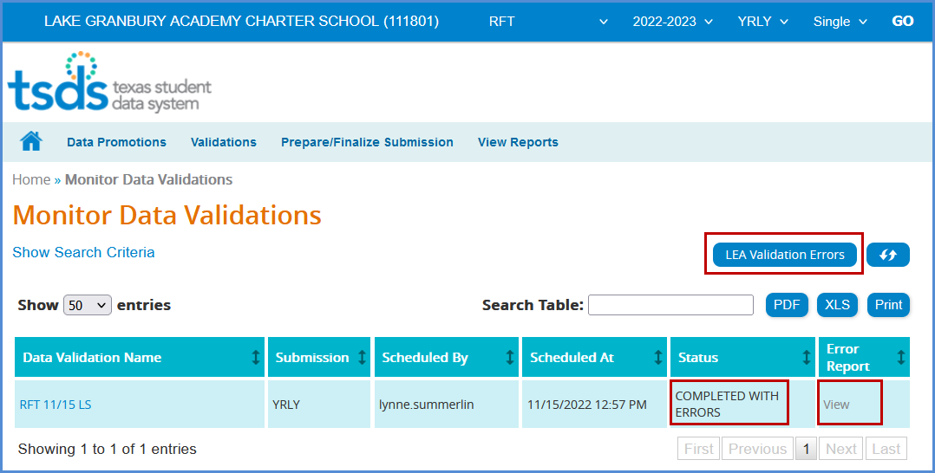

- This screen shows the status of the data validations, validation error reports, and a confirmation message that the data has been submitted.
- To view validation errors by job, click the LEA Validation Errors button or View under Error Report.
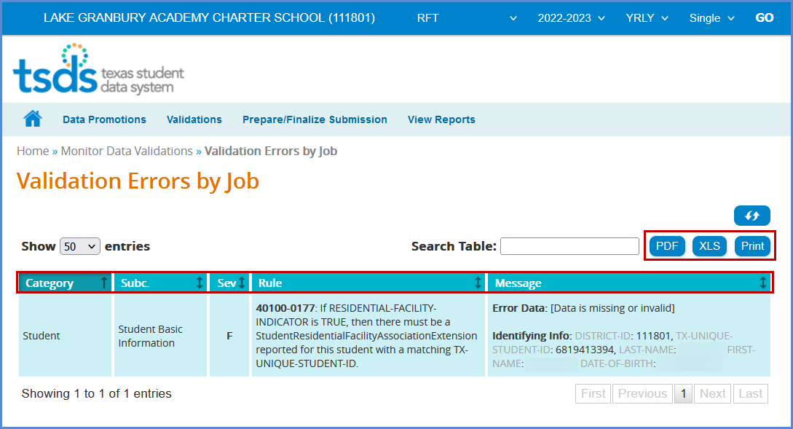

- This screen will list any errors by Category, Subcategory, Severity, along with the error message.
- Errors can be sorted by the individual columns. The errors can also be saved as a PDF or XLS file or can be printed by selecting the appropriate button.
- The Search Table option can be used to search the errors by any field such as Rule Number, Student UID, specific Category or Subcategory, etc.

Note: It is recommended that the district use the Delete Utility in TSDS>Manage Data Loads to clear the incorrect data from the ODS prior to uploading the new files.

View Reports – RFT Reports

Reports must be run and verified prior to and after completing the RFT data submission. There are currently four reports available:

- Archived Legacy Reports
- RFT0-100-001 RFT Comparison of Student Instructional Minutes
- RFT0-100-002 Residential Facilities
- RFT0-100-003 Residential Facility End of Year Verification
- RFT0-100-004 Individual Student Detail Summary

To access the reports:

- Log in to TEAL and select Texas Student Data System Portal.
- On the Home screen select RFT under View Reports. Click View Reports.

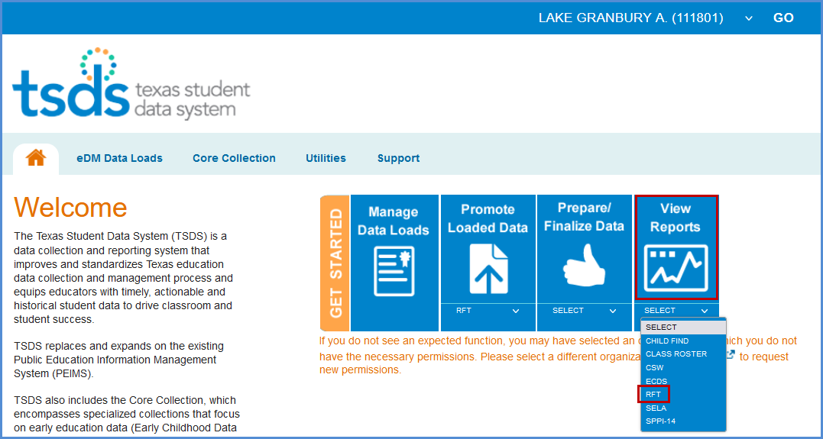

- Or, reports can be accessed in Core Collection > RFT > View Reports.

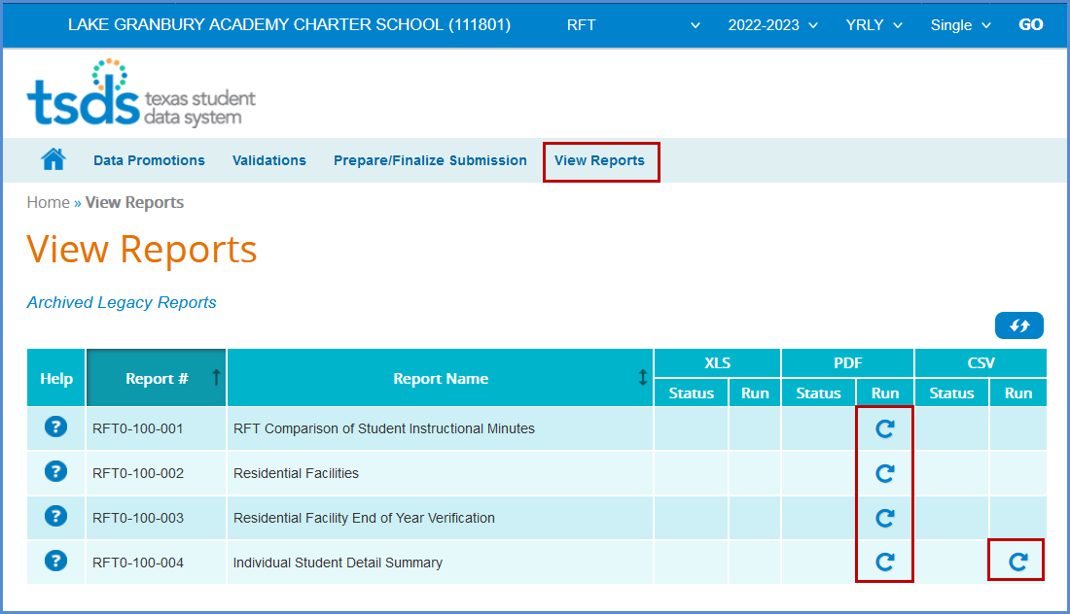

- Under View Reports, click the arrow in the Run column for the appropriate report.
- The Residential Facilities report requires Parameters be selected. Select the appropriate parameters and click Run.

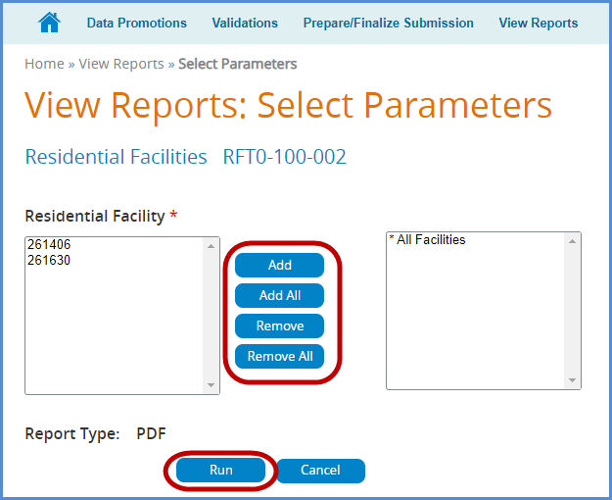

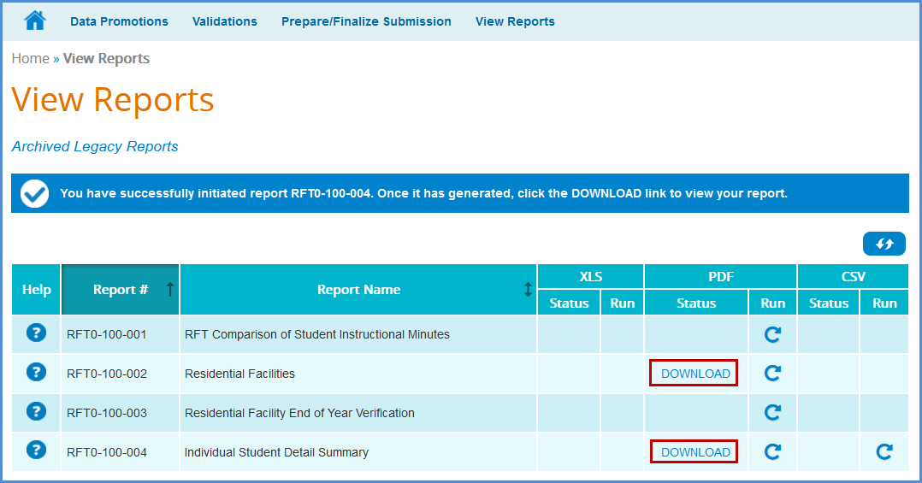
- Click Download to view the reports.
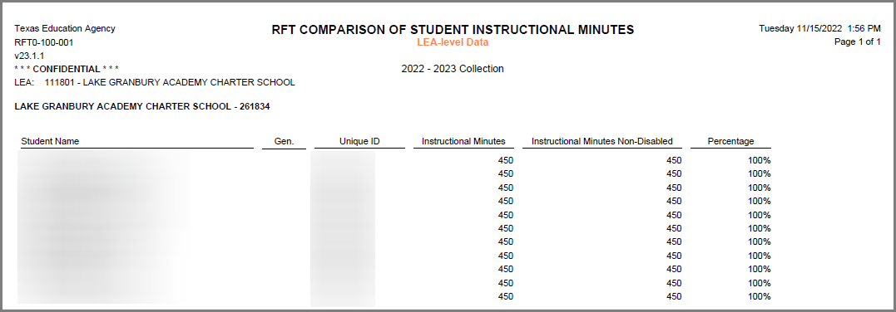
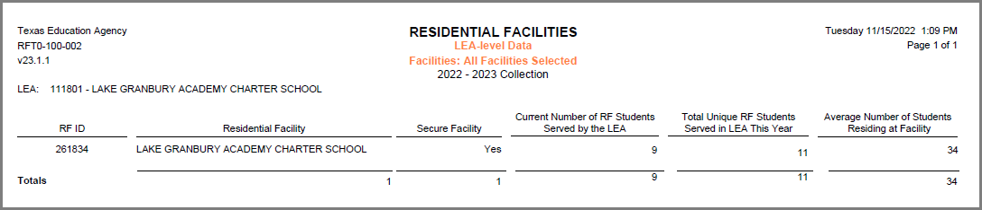
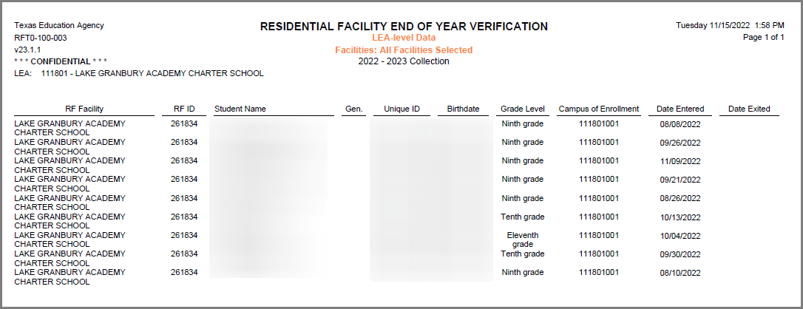

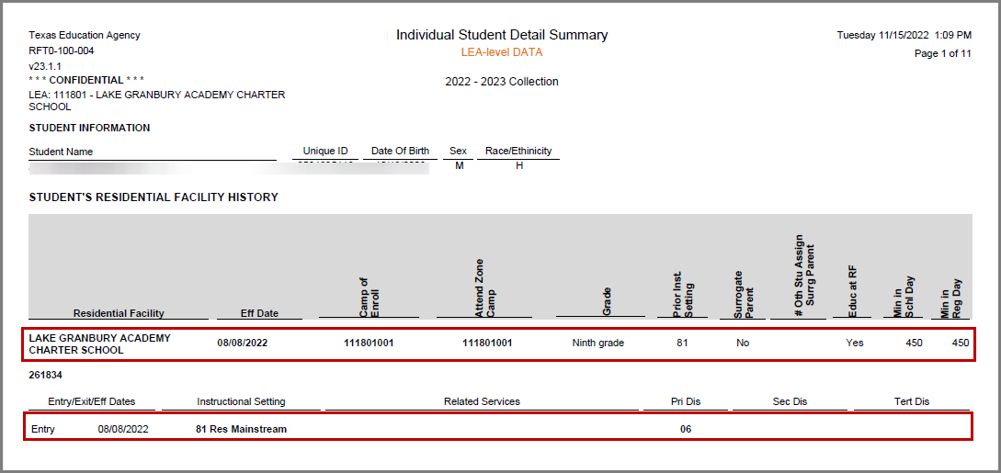
- To view previous year data, Click Archived Legacy Reports.

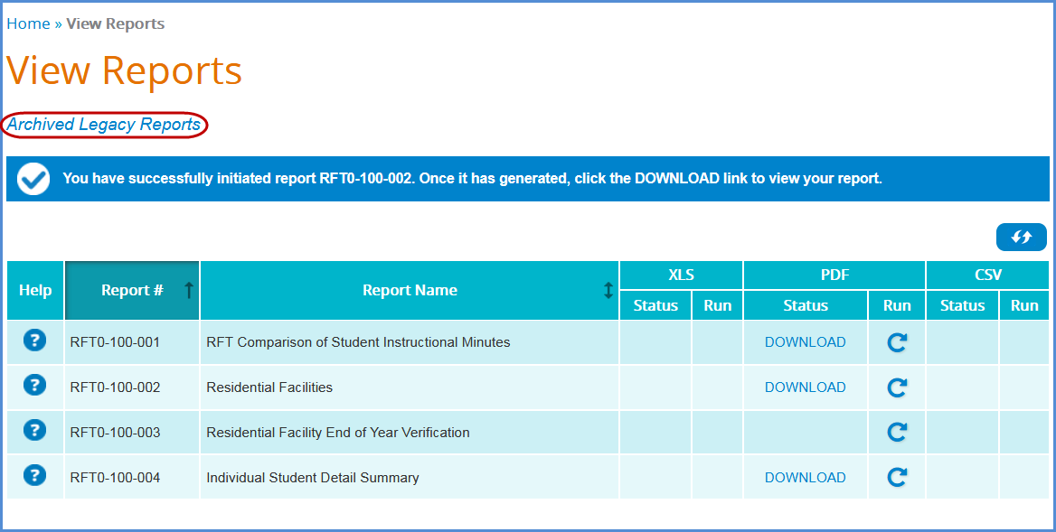

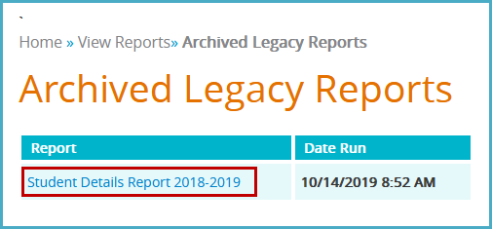

TSDS – Core RFT Prepare/Finalize Process

AT THE END OF THE SCHOOL YEAR DISTRICTS WILL PREPARE/FINALIZE THE RFT SUBMISSION. Once data has been validated, the district will prepare and finalize the data which will include completing the process. This process will be covered in a webinar near the end of the school year prior to the actual due date to TEA.

Do not hit Complete prior to the end of the year.

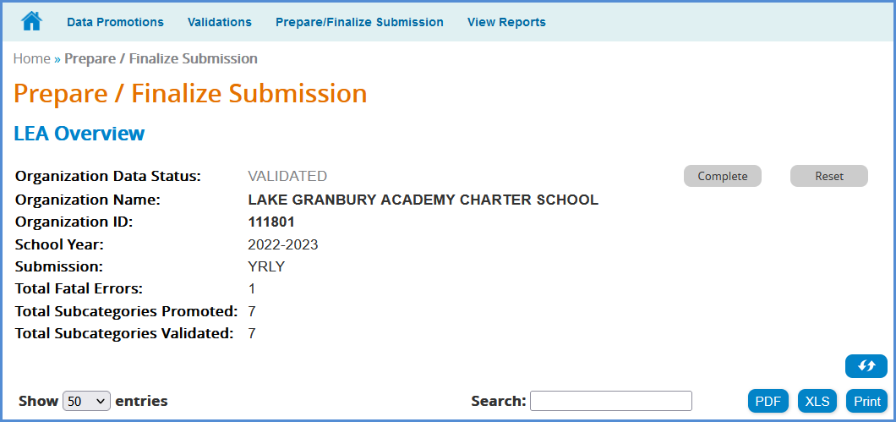
0

ESC Region 11 grants permission to attendees of this session to reproduce and distribute designated resources and materials provided during the presentation.

